# ­­Our Company

Capabilities Overview

ANALYTICA has built a team of exceptionally dedicated analysts, statisticians, developers, engineers, and professionals with a wide range of experiences and talents. As the 4th fastest-growing IT services company in the nation, our team is ever-expanding to broaden our technology capabilities and expertise. ANALYTICA’s team members are united in their commitment to leveraging data and advanced data analytic technologies to solve the world’s most pressing and important problems. We value our start-up culture: we work hard, but we know how to have fun. As one of a select group of companies capable of bridging the gap between functional silos, ANALYTICA specializes in providing a holistic approach to an organization’s financial, analytics, and information technology needs.

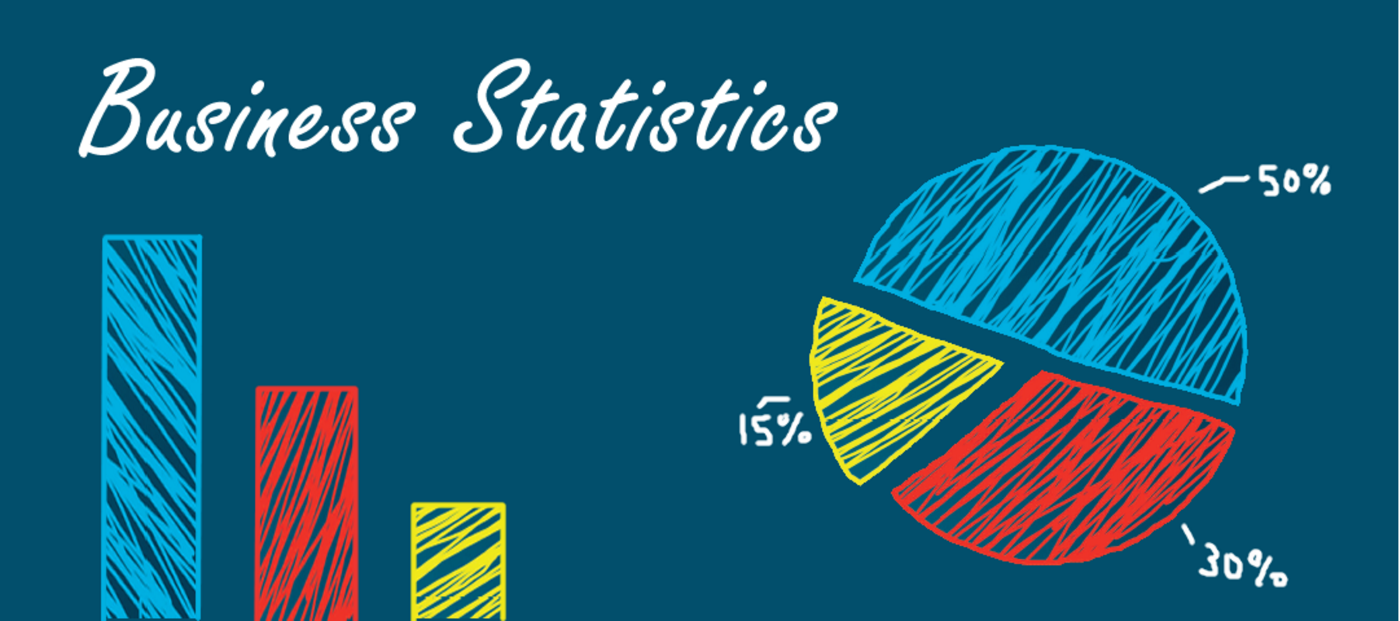

# Our Team

Lorem ipsum dolor sit amet, consectetuer adipiscing elit, sed diam nonummy nibh euismod tincidunt ut laoreet dolore magna aliquam erat volutpat. Ut wisi enim ad minim veniam, quis nostrud exerci tation.

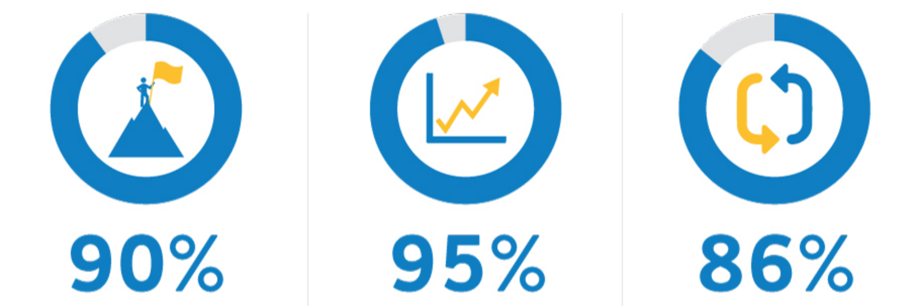

# Our Certifications



|  |  |
| --- | --- |
| Service Areas | |
|  | **Information Management**  Ensuring organizations have the architectural foundation, policies, practices, tools, and procedures to maintain data across the lifecycle is properly managed and available to front line workers. | |
|  | **Analytics & Visualization**  Providing industries and organizations with the ability to explore data to create and refine strategies for delivering data-driven insights. Various techniques ranging from simple trend analysis to predictive or event driven analytics can be used to assess, dissect, scrutinize, and interpret information. | |
|  | **Software & Systems Engineering**  Develop, integrate, manage, and maintain software and systems environments that allow organizations to operate more efficiently. | |
|  | **Management Consulting**  Assisting organizations adapt to changing external, technological, and end-user needs. | |
|  | **Cyber Security**  Mitigating risks of cyber-attacks through a structured cyber security services model. Combining strategy and technology to offer tailored cyber security solutions to fit an organization’s needs. | |

Capabilities Overview